Elevator System Usage Efficiency: Applying Human Detection Monitor using Computer Vision approach

Sarah Karissa
School Of Computer Science
Bina Nusantara University
Jakarta, 14480, Indonesia
karissa.sarah@binus.ac.id

Panji Arisaputra
Computer Science Departement School Of Computer Science
Bina Nusantara University
Jakarta, 14480, Indonesia
panji.arisaputra@binus.ac.id
Marsyanda Indiyana Maslikan
School Of Computer Science
Bina Nusantara University
Jakarta, 14480, Indonesia
marsyanda.maslikan@binus.ac.id

Benny Strata Wijaya
School Of Computer Science
Bina Nusantara University
Jakarta, 14480, Indonesia
benny.wijaya002@binus.ac.id

David David
Computer Science Departement School Of Computer Science
Bina Nusantara University
Jakarta, 14480, Indonesia
david01@binus.edu

Abstract - An efficient elevator system that has good security is a very important system to apply to high-rise buildings. The use of elevators is arguably a necessity in accelerating a person's desire to get to the desired floor, especially in a rustic building, to be sure that time is precious there. What they call time is money, so they don't want the elevator system to be able to keep up with it. Therefore, this paper was created to increase the efficiency of elevator systems using a computer vision approach. This system will later be proposed using camera-based settings that can be monitored using real-time monitors. The camera will also be designed to detect more accurately with batons such as CNN (Conventional Neural Network), YOLO (You Only Look Once), and Motion Detection.

Keywords—elevator system, computer vision, YOLO, Human Detection, Facial Recognition, Motion Detection, CNN.

Introduction

Background

Elevator is a vertical transportation that facilitates the mobility of users to get up and down the building quickly and efficiently, along with technological developments and urbanisation, more and more high-rise buildings are being built in big cities. Therefore, elevators are very important to facilitate human mobility in these buildings. However, there is a trivial problem regarding the use of the elevator that we often encounter, even though it is trivial but it is quite time consuming, namely when someone presses the elevator button but the person leaves it, the elevator will automatically move to that floor even though the person have left their place, the elevator only carries out their orders without actually knowing whether they wanted to use the elevator or not, therefore our group wants to help solve this problem by providing sensors / camera as the "eyes" of the elevator so that the elevator knows whether it should go to the designated floor or not .

Problem Statements
Based on the background, we can state that there are some problems that lead us to conclude that technology will never cease. As the young generation we are required to keep up with those developments so that we don't fall behind. This will be a difficult challenge to overcome, especially in daily life. Like the use of an elevator that's been used so often throughout office buildings and schools, there are even some residential houses that we used to know were just manual stairs, now that we've started using elevators to speed them up to their intended floors. Therefore, the speed and safety of an elevator must be carefully considered and detailed. Moreover, there are many systems that can be combined into the operation of elevators to make them faster. But here are some of the problems with implementing the system: what kind of system is right to use in this elevator problem? We had to do detailed research so that there would be no mistakes in selecting a system that would cause a loss in any way.

Research Purpose
In a study, it certainly has some purpose in explaining why the study was conducted. Seeing how many people choose to use elevators when they go to the floor of a building allows them to be used more and more frequently. However, many features of elevators are still less supportive in order to operate more quickly. Therefore, we did this research that could be realized and could help people be comfortable when using elevators.
The purpose is to help elevator users know how many people are in the elevator because, usually, when we're waiting for an elevator that doesn't have full seating, it's already full of people, so we don't have to wait for the elevator. This will help speed up the people who wait to go to the floor they are on, such as by using another elevator or an escalator. Elevators can also help minimize stops on floors where no one is there, or, in other words, someone who wants to use the elevator but leaves because it's too long to wait. So, in this system, those in the elevator will be able to see whether or not there are people waiting for the elevator; otherwise, they can immediately turn off the elevator button for the floor, and then the elevator won't stop on the floor. This research that we're doing will also make the elevator work faster because, as previously explained, it can turn off the elevator button from the inside when it sees that no one is waiting on the floor and make the elevator stop on the floor.

LITERATURE REVIEW

Elevator System
Elevators are widely used in high-rise buildings, where they also require a good and safe system while the elevators are in operation. Elevator systems also have a variety of components in them and each component has different purposes. These components can be like a control system that functions to see the performance of the elevator. From the components we will try to improve the performance by increasing the detection around the elevator.

Computer Vision models for Elevator System
Creating a more efficient elevator system requires us to look at every angle, such as safety, speed, and performance of the elevator itself. To support this, using computer vision is the most appropriate way because computer vision is able to solve the problem with satisfactory results. The results from computer vision detection are also more accurate and it will allow the elevator system to adapt better to the environment that surrounds it. Computer Vision can even provide the best experience for users. The use of computer vision in elevator systems also makes it easier for us to monitor real-time and thorough movement of elevators in those elevator areas. The profound capabilities of computer vision really helped us through this research because the computer vision method helps us to realize all kinds of problems in elevator systems.

Related Work
This literature review aims to find comparisons through previous research on computer vision and machine learning applicated to Facial recognition or human recognition for our improving elevator system. By analyzing this articles that have use different methods such as CNN, DNN, ANN, PCA, SVM, etc.

Some studies that we have found can be traced back to the time where our society first experienced COVID-19 where there very limited technologies implementation of facial recognition to the public, the study from Pankaj, K. & Vishan, K. (2023) states “Even though the original dataset was limited, the Convolutional Neural Network (CNN) model achieved exceptional accuracy utilizing the deep learning technique.” which the accuracy of 100% was reached by combining Python, OpenCV, Tensor Flow, and Keras. [1] There are other methods that also result in high accuracy, as it states on another study by Anuj, K. S. & Aryan, V. Harsh, P. & Udit, R. & Arjun N. & Lucky, S. (2023) “YOLO is a powerful tool for human detection and crowd counting, offering speed, efficiency, and state-of-the art performance.” where YOLO proves to be a good new method for help build the system. [2] Another study from Ibraheem, M. &. (2023) “Despite the high accuracy of the YOLOv5 algorithm in detecting the people in the image, video or real-time camera capturing, it needs an increase in speed. For this reason, the YOLOv5 algorithm was combined with the KCF tracking algorithm. Where the YOLOv5 algorithm identifies people to be tracked by the KCF.” where the accuracy hits 98% [3] Another study by Peng, B. &. (2021) states “The proposed approach, which combines CNN with the augmented face dataset, can achieve a higher face recognition accuracy than others“ where the CNN method combined with augmented dataset reached 99.5% accuracy compared to ANN that reached 80.3%, and other methods [4] However, for real time video detection a study by Wahyu, A. &. (2021) states “SSD MobileNet V2 is a model that can detect humans on our datasets more accurately and faster than other models in the jetson inference, such as PedNet, multiped, SSD MobileNet V1, and SSD inception V2.” That proves that the methods above while effective needs to have a more complex model in order to maximize the results [5]

Our research is also involved on determining whether the application of a computer vision-based method is appropriate when applied to everyday activities such as applying it to useful elevators increases its efficiency. Computer Vision technology allows the use of cameras to detect the number of people who want to take the elevator, count the number of people in the elevator, and predict each user's destination. [18] The use of several computer vision-based methods such as applying self-starting motors to electric vehicles, an anomaly detection algorithm that can also be used as a performance monitor of the elevator. For example, when there's a time waiting for an elevator becomes too long, this anomalous detection can predict things like that so it can better optimize some of the functions of the elevator [15][6][19]. If efficiency has been successfully implemented, this time safety must be carefully considered so that elevator users can remain safe and minimize accidents using elevators. Elevator systems can be added with obstacle validation to ensure that the elevator moves safely and in control [8]. The application of obstacle validation can be by fitting sensors or cameras that support wide areas where they can provide a wide view so that they reduce the risk of crime in elevators [7]. Safety on elevators also needs to be validated, and repeated tests of all aspects are indispensable because they can minimize damage for long periods of time [11].

Performance improvement on elevators through the help of motion detection is also a good option because motion detection can detect any movement around the elevator as it stated from the research above. Motion detection can get elevators to save energy especially in high – rise building. [17[19][20] With the use of motion detection not just getting a high level of security, but to perfect an elevator system, we can combine it with an automata because they can both be used to improve system performance [16][10]. If motion detection can detect any movement around the elevator, applying the additional Haar-like HopeNet method is also helpful for optimization of system performance as it can be used for face detection and facial emotion recognition by performing data management techniques using PCA (Principal Component Analysis) which also helps in identifying each movement in the brain around the elevator [9][14]. With data management that has already been done through PCA, the machine learning techniques can use Deep Autoencoders combined with SVM (Support Vector Machine) as they can help elevator systems detect more accurately, where both techniques can ensure that only humans and goods ride the elevator [14]. Whereas to help create a mathematical model, we can use the modeling embedded system on the elevator system [12]. Modeling embedded systems are also able to perform system maintenance well.

It can be concluded that the right model is crucial in the interest for the success of the research. This review also shows that the use of combined methods tends to improve the accuracy on the system or the model.

Methodology

Type of research
The methods used in this study will focus more on methods for face detection and increased efficiency in elevator systems. Where we use several methodologies such as CNN (Conventional Neural Network), YOLO (You Only Look Once), and Motion Detection. CNN is a deep learning model designed to process two-dimensional data, which can also produce high accuracy on output. This method can be implemented on an elevator system as in face recognition using a wide-area camera where it can provide a wide view so that it reduces the risk of crime in elevators, not just faces, but also faces. CNN can be used to identify items such as bags or other items. This can help improve safety in elevators, in the event of unwanted things. Meanwhile, the second method we chose is YOLO (You Only Look Once), we think YOLO is the right method to use in elevator systems.

YOLO (You Only Look Once) is a method for detecting real-time objects with the aim of detecting objects efficiently and accurately, where YOLO and CNN are combined to achieve better accuracy. YOLO can also be used to detect certain objects or behaviors in an elevator; this method can determine whether the elevator is functioning properly. Where the use of YOLO is particularly necessary, this method is capable of maintaining safety in elevators and making elevators more efficient.

After determining the method for making elevators more efficient, the next thing to do is improve the performance of elevators with the help of motion detection methods. This method of detection can detect any movement around the elevator, even motion detection can make the elevator to save energy, and it can be used to detect any movement around the elevator. So when the elevator is empty, the system can immediately turn off the lights and the elevator can stop for a moment (like parking) on the ground floor when no one gets on the elevator. So, by using motion detection instead of just getting a high level of security, we're also able to save energy.

Data collection process
- Literature
Find literature from journals and other papers related to our research. Collecting data in this way will make it easier to refine the research that we're doing.
- Survey
Once the literacy process is done, we will conduct a survey to get more and more accurate data. With data collection in the form of surveys, we can get to know from the perspective of users, where this assessment needs their perspective.
- Observation
If literature and surveys have been conducted, the next data collection process is an observation of the results of previous data collection. We will focus more on the problems that users are experiencing and achieving the goals of our research.

Data analysis process
In this process all the data and methods we've collected will be analysed one by one in detail. This aims to find out if the methods we choose are in line with our research needs, as well as in the process of analyzing the data that is being inspected whether it has answered problems from users. If there are some things that aren't quite right, then we will refine the method to make it easier to achieve the goals of the study.

Resource, materials and tools
In a study focusing on face detection, we took a dataset of images of human faces from all sides and surrounding conditions as sensors performed their tasks. This can make research more accurate because it has a lot of data in use and can minimize errors in sensors.

Here are some examples of the dataset we used:
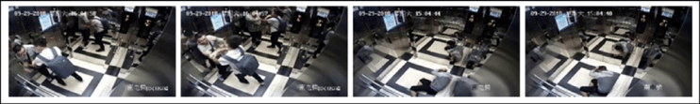
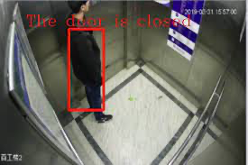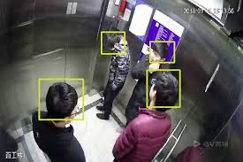
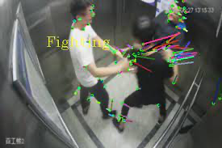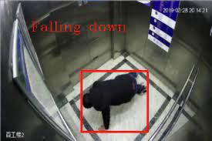

Rationale behind the research
In the research that we do, we use assistance from the Artificial Intelligence branch, namely Computer Vision and by providing pictures and train models so that our machine can more easily and accurately make decisions about cancelling elevators and providing information about the number of people in the elevator.

RESULT AND EVALUATION
- Download and Install Library
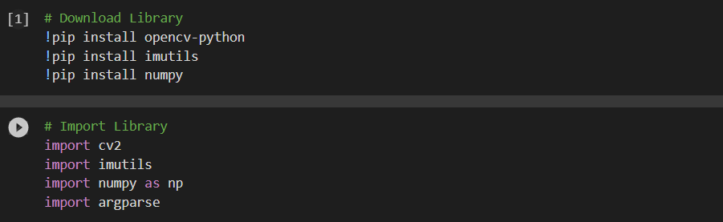
- Load the pre-trained YOLOv3 model
- Set the labels for the YOLO model
- Load the image or video

- Obtain the image dimensions

- Create a blob from the input image
- Set the input blob for the network
- Perform forward pass and get the output layer names
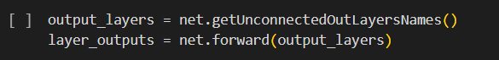
- Initialize lists to store bounding box coordinates and confidences

- Loop over each output layer
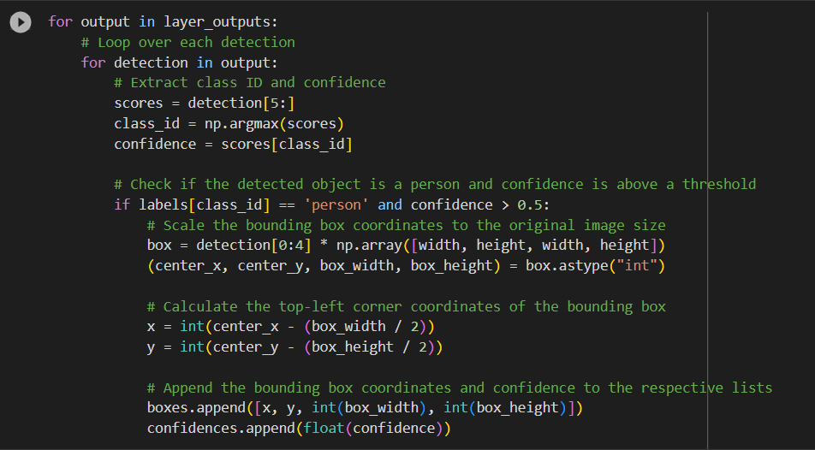
- Apply non-maximum suppression to remove overlapping bounding boxes
- Draw bounding boxes and labels on the image
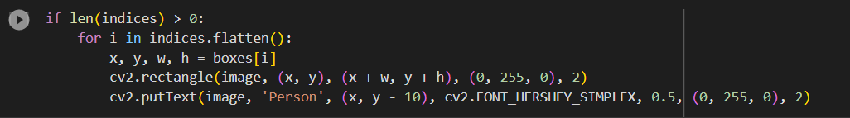
- Display the resulting image


CONCLUSIONS

References
- Pankaj Kumar, Vishan Kumar Gupta, Devesh Pratap Singh (2023) “Face Mask Detection using Convolution Neural Network.” https://orcid.org/0000-0001-7245-3824, March. 2023.
- Anuj, K. S. & Aryan, V. Harsh, P. & Udit, R. & Arjun N. & Lucky, S. (2023). “HUMAN DETECTION AND CROWDCOUNTING USING YOLO.” Department of CSE(AIML), Acropolis Institute of Technology and Research Institute, Indore, India. March. 2023.
- Ibraheem, M. &. (2023). “Crowd counting using Yolov5 and KCF”. Periodicals of Engineering and Natural Sciences. Vol. 11, No. 2, March 2023, pp.92-101, March. 2023.
- P. Lua, B. Song, and L. Xu(2020). “Human face recognition based on convolutional neural network and augmented dataset.” SYSTEMS SCIENCE & CONTROL ENGINEERING: AN OPEN ACCESS JOURNAL 2021, VOL. 9, NO. S2, 29–37 https://doi.org/10.1080/21642583.2020.1836526, October. 2020.
- Wahyu, A. &. (2021). “Real-Time Human Detection Using Deep Learning on Embedded Platforms: A Review”. Journal of Robotics and Control (JRC) Volume 2, Issue 6, DOI: 10.18196/jrc.26123, November. 2021.
- I. Munteanu and A. I. Bratcu, “HILS-based Demonstrator for Real-time Validation of Robust Control Strategies: An Electric Vehicle Application Case,” IEEE Trans. Ind. Electron., vol. 67, no. 6, pp. 4967–4977, Jun. 2023.
- B. Faure, N. Odic, O. Haggui, and B. Magnier, “Performance of Recent tiny/small YOLO Versions in the Context of Top-view Fisheye Images,” IEEE Access, vol. 9, pp. 246-257, May. 2022
- W. M. Martins, F. Mora-Camino, and A. C. Brandao-Ramos, “A Computer Vision Based Algorithm for Obstacle Avoidance (Outdoor Flight),” IEEE Latin America Trans., vol. 16, no. 10, pp. 569-575, Feb. 2018.
- E. D. Cenzi and M. Rudek, “A Method to Gaze Following Detection by Computer Vision Applied to Production Environments,” IEEE Access, vol. 8, pp. 36-49, Aug. 2022.
- D. J. Chen, R. Anthony, M. Persson, D. Scholle, V. Friesen, G. Deboer, A. Rettberg, and C. Ekelin, "An Architectural Approach to Autonomics and Self-management of Automotive Embedded Electronic Systems," IEEE Trans. Intell. Transp. Syst., vol. 12, no. 3, pp. 808-821, Aug. 2019.
- F. Corbier, S. Loembe, and B. Clark, "FMI technology for validation of embedded electronic systems," in Proc. IEEE Int. Conf. on Industrial Informatics (INDIN), Emden, Germany, Jul. 2016, pp. 607-612, Aug.2019.
- M. Weber, S. Klug, E. Sax, and B. Zimmer, "Embedded Hybrid Anomaly Detection for Automotive CAN Communication," IEEE Trans. Veh. Technol., vol. 67, no. 5, pp. 3945-3957, Feb. 2018.
- G. Raghav, S. Gopalswamy, K. Radhakrishnan, J. Hugues, and J. Delange, "Model Based Code Generation for Distributed Embedded Systems," IEEE Trans. Ind. Informatics, vol. 13, no. 3, pp. 1394-1405, Aug. 2019.
- N. Cohen, I. Tzachor, and Y. Hoshen, "Set Features for Fine-grained Anomaly Detection," IEEE Trans. Pattern Anal. Mach. Intell., vol. 43, no. 4, pp. 1264-1274, Sep. 2022.
- R. Rill-García, E. Dokladalova, P. Dokládal, J.-F. Caron, R. Mesnil, P. Margerit, and M. Charrier, "Inline Monitoring of 3D Concrete Printing using Computer Vision," IEEE Trans. Ind. Informatics, vol. 17, no. 9, pp. 6231–6239, Sep. 2021.
- N. Mokhtari, A. Nédélec, and P. de Loor, “Human Activity Recognition: A Spatio-temporal Image Encoding of 3D Skeleton Data for Online Action Detection,” IEEE Trans. Multimed., vol. 22, no. 4, pp. 448-466, Mar. 2023.
- L. Er-Rajy, A. M. El Kiram, and M. El Ghazouani, "Real-time human body detection in surveillance footage using computer vision algorithms," International Journal of Advanced Computer Science and Applications, vol. 11, no. 9, pp. 115–122, 2020. DOI: 10.14569/IJACSA.2020.0110916.
- A. Brunetti, D. Buongiorno, G. F. Trotta, and V. Bevilacqua, "Computer vision and deep learning techniques for pedestrian detection and tracking: A survey," Neurocomputing, vol. 300, pp. 74-87, Sep. 2018, DOI: 10.1016/j.neucom.2017.12.016.

- R. Suganthalakshmi, A. Hafeeza, P. Abinaya, and A. Ganga Devi, "Covid-19 facemask detection with deep learning and computer vision," in 2021 International Conference on Data Engineering and Communication Technology (ICDECT), Chennai, India, 2021, pp. 131-136, doi: 10.1109/ICDECT51858.2021.9370349.
- A. Kumar, A. Kaur, and M. Kumar, "Face detection techniques: a review," in Proceedings of the 2016 2nd International Conference on Next Generation Computing Technologies (NGCT), Dehradun, India, 2016, pp. 298-302, doi: 10.1109/NGCT.2016.7877478.
- P. Wang, W. Li, P. Ogunbona, J. Wan, and S. Escalera, "RGB-D-based human motion recognition with deep learning: A survey," IEEE Transactions on Pattern Analysis and Machine Intelligence, vol. 40, no. 10, pp. 2572-2594, Oct. 2018.

